1. **Agenda:**
   1. How to create a WireMock Stub for an endpoint that is going to return a 400 status code as response.
2. 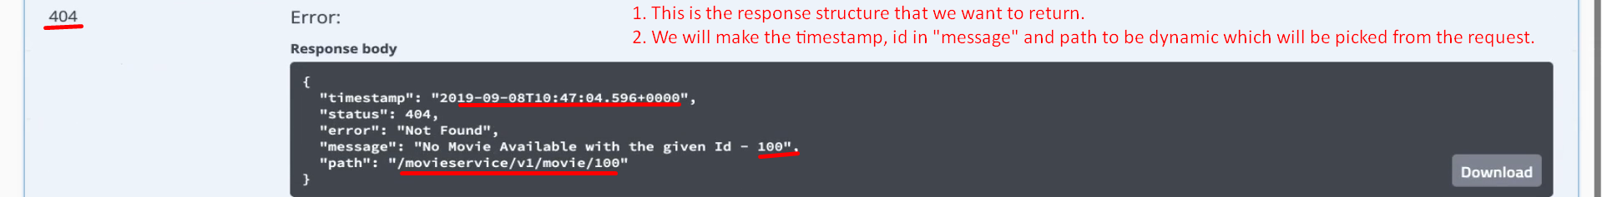
3. 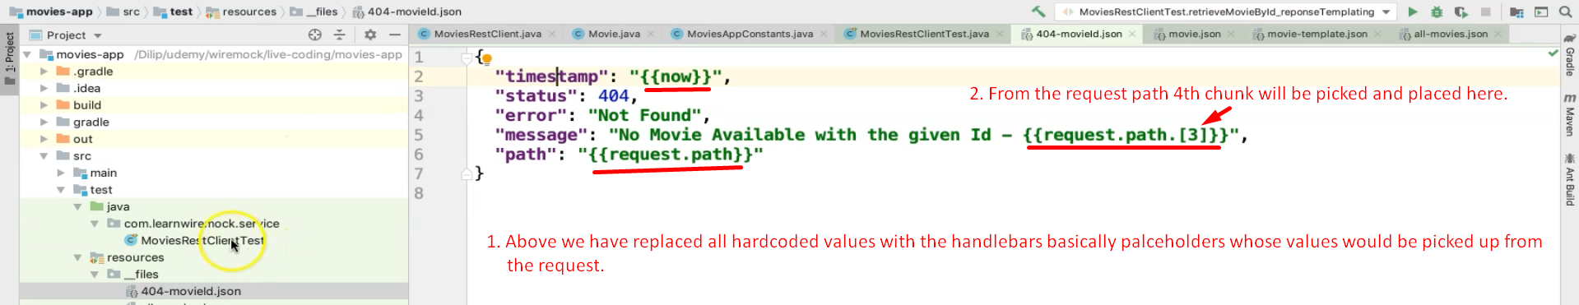
4. 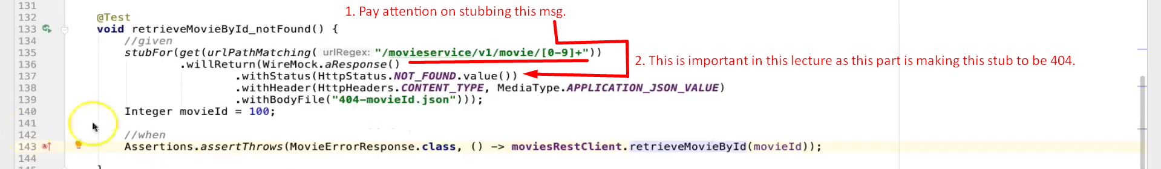
5. 